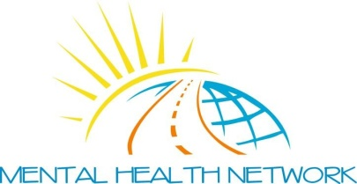
Date

WHY NOT BECOME A MEMBER OF THE MENTAL HEALTH NETWORK?

Forename Surname

Address

Post Code

Tel No Mobile No

Email Address

Gender (please tick) Male Female
Age (please tick)

16-20 21-30 31-40 41-50 51-60 60+

Nationality
LOCATION | Please Tick
Glasgow North East
Glasgow North West
Glasgow South
East Dunbartonshire
West Dunbartonshire
Renfrewshire
East Renfrewshire
Inverclyde
Other

HEALTH STATUS | Please Tick
No Disability or Impairment
Mental Health Condition
Physical Impairment
Sensory Impairment
Learning Disability
Carer

.

By completing this form, I agree to the following Data Protection conditions:

The Mental Health Network (Greater Glasgow) is a non profit making organisation. We will only use the details on this form to send you our newsletter and other relevant information. We will securely hold this data until you contact us and ask for it to be deleted for any reason. If you have included your email address on this form, please note that we use a third party email suite (MailchimpTM) to manage our email distribution list.

Please return to: Mental Health Network, Suite 11, Templeton Business Centre, 62 Templeton Street, Glasgow, G40 1DA

